TIME INTELLIGENCE FUNCTIONS
NOTE: Time intelligence function means doing calculations over periods of dates or time.
This function will need a Date column to perform the calculations.
The Date column should contain unique, non-blank and contiguous date values to getting the accurate results.
This function can apply in “New measure” why because it returns a scalar value and does not support direct query mode.
INPUT DATA: 1) time -----table
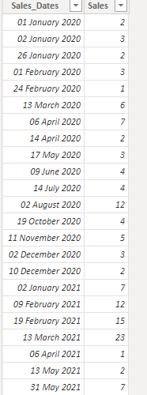
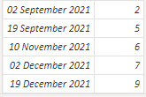

1) CLOSINGBALANCEMONTH: By using this, in that date column what ever the last date of the Month is there, that date related value will be displayed for the specified columns of date.
Syntax: CLOSINGBALANCEMONTH(<expression>,<dates>[,<filter>])
Dax Function: CBM = CLOSINGBALANCEMONTH(SUM('time'[Sales]),'time'[Sales_Dates])

2) CLOSINGBALANCEQUARTER: By using this, in that date column whatever the last date of the Quarter is there, that date related value will be displayed for the specified columns of date.
Syntax: CLOSINGBALANCEQUARTER(<expression>,<dates>[,<filter>])
Dax Function: CBQ = CLOSINGBALANCEQUARTER(SUM('time'[Sales]),'time'[Sales_Dates])

3) CLOSINGBALANCEYEAR: By using this, in that date column whatever the last date of the Year is there, that date related value will be displayed for the specified columns of date.
Syntax: CLOSINGBALANCEYEAR(<expression>,<dates>[,<filter>][,<year_end_date>])
Dax Function: CBY = CLOSINGBALANCEYEAR(SUM('time'[Sales]),'time'[Sales_Dates])

4) OPININGBALANCEMONTH: By using this, in that date column whatever the first date of the Month is there, that date related value will be displayed for the specified columns of date.
Syntax: OPENINGBALANCEMONTH(<expression>,<dates>[,<filter>])
Dax Function: OBM = OPENINGBALANCEMONTH(SUM('time'[Sales]),'time'[Sales_Dates])

5) OPININGBALANCEQUARTER: By using this, in that date column whatever the first date of the Quarter is there, that date related value will be displayed for the specified columns of date.
Syntax: OPENINGBALANCEQUARTER(<expression>,<dates>[,<filter>])
Dax Function: OBQ = OPENINGBALANCEQUARTER(SUM('time'[Sales]),'time'[Sales_Dates])
6) OPININGBALANCEYEAR: By using this, in that date column whatever the first date of the Year is there, that date related value will be displayed for the specified columns of date.
Syntax: OPENINGBALANCEYEAR(<expression>,<dates>[,<filter>][,<year_end_date>])
Dax Function: OBY = OPENINGBALANCEYEAR(SUM('time'[Sales]),'time'[Sales_Dates])
Output:
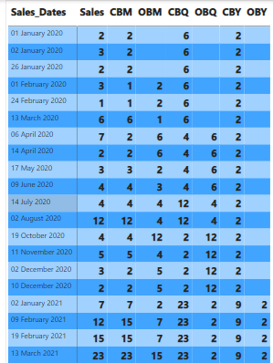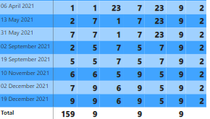

7)STARTOFMONTH : By using this, in that date column whatever the earliest date is there based on month , that date related value will be displayed for the specified columns of date.
Syntax: STARTOFMONTH(<dates>)
Dax Function: SM = STARTOFMONTH('time'[Sales_Dates])&":"& CALCULATE(SUM('time'[Sales]),STARTOFMONTH('time'[Sales_Dates]))

8)STARTOFQUARTER : By using this, in that date column whatever the earliest date is there based on Quarter , that date related value will be displayed for the specified columns of date.
Syntax: STARTOFQUARTER(<dates>)
Dax Function: SQ = STARTOFQUARTER('time'[Sales_Dates])&":"& CALCULATE(SUM('time'[Sales]),STARTOFQUARTER('time'[Sales_Dates]))
9)STARTOFYEAR : By using this, in that date column whatever the earliest date is there based on Year , that date related value will be displayed for the specified columns of date.
Syntax: STARTOFYEAR(<dates>)
Dax Function: SY = STARTOFYEAR('time'[Sales_Dates])&":"& CALCULATE(SUM('time'[Sales]),STARTOFYEAR('time'[Sales_Dates]))

10)ENDOFMONTH : By using this, in that date column whatever the latest date is there based on Month , that date related value will be displayed for the specified columns of date.
Syntax: ENDOFMONTH(<dates>)
Dax Function: EM = CALCULATE(SUM('time'[Sales]),ENDOFMONTH('time'[Sales_Dates]))

11)ENDOFQUARTER : By using this, in that date column whatever the latest date is there based on Quarter , that date related value will be displayed for the specified columns of date.
Syntax: ENDOFQUARTER(<dates>)
Dax Function: EQ = CALCULATE(SUM('time'[Sales]),ENDOFQUARTER('time'[Sales_Dates]))

12)ENDOFYEAR : By using this, in that date column whatever the latest date is there based on Year , that date related value will be displayed for the specified columns of date.
Syntax: ENDOFYEAR(<dates> [,<year_end_date>])
Dax Function: EY = CALCULATE(SUM('time'[Sales]),ENDOFYEAR('time'[Sales_Dates]))

Output:
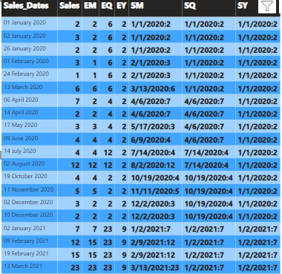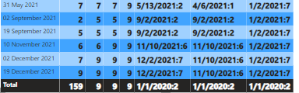

13)FIRSTDATE: By using this, in that date column whatever the First date is there, that date related value will be displayed for the specified columns of date.
Syntax: FIRSTDATE(<dates>)
Dax Function: FD = CALCULATE(SUM('time'[Sales]),FIRSTDATE('time'[Sales_Dates]))

14)LASTDATE: By using this, in that date column whatever the Last date is there, that date related value will be displayed for the specified columns of date.
Syntax: LASTDATE(<dates>)
Dax Function: LD = CALCULATE(SUM('time'[Sales]),LASTDATE('time'[Sales_Dates]))

Output:
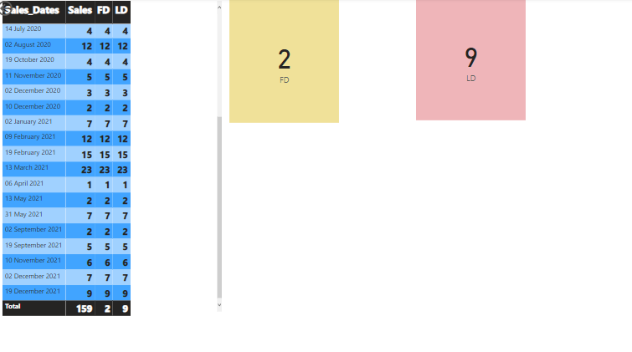
15)NEXTDAY : By using this, in that date column whatever the Next date is there based on First date, that date related value will be displayed for the specified columns of date.
Syntax: NEXTDAY(<dates>)
Dax Function: ND = CALCULATE(SUM('time'[Sales]),NEXTDAY('time'[Sales_Dates]))
16)NEXTMONTH : By using this, in that date column whatever the Next Month is there based on First date, that date related value will be displayed for the specified columns of date.
Syntax: NEXTMONTH(<dates>)
Dax Function: NM = CALCULATE(SUM('time'[Sales]),NEXTMONTH('time'[Sales_Dates]))
17)NEXTQUARTER :By using this, in that date column whatever the Next Quarter is there based on First date, that date related value will be displayed for the specified columns of date.
Syntax: NEXTQUARTER(<dates>)
Dax Function: NQ = CALCULATE(SUM('time'[Sales]),NEXTQUARTER('time'[Sales_Dates]))
18)NEXTYEAR : :By using this, in that date column whatever the Next Year is there based on First date, that date related value will be displayed for the specified columns of date.
Syntax: NEXTYEAR(<dates>[,<year_end_date>])
Dax Function: NY = CALCULATE(SUM('time'[Sales]),NEXTYEAR('time'[Sales_Dates]))

Output:
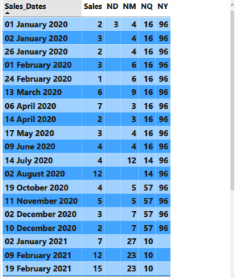
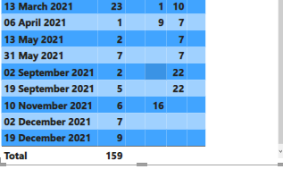
19)PREVIOUSDAY : By using this, in that date column whatever the Previous Date is there, that date related value will be displayed for the specified columns of date.
Syntax: PREVIOUSDAY(<dates>)
Dax Function: PD = CALCULATE(SUM('time'[Sales]),PREVIOUSDAY('time'[Sales_Dates]))
20)PREVIOUSMONTH : By using this, in that date column whatever the Previous Month is there, that date related value will be displayed for the specified columns of date.
Syntax: PREVIOUSMONTH(<Dates>)
Dax Function: PM = CALCULATE(SUM('time'[Sales]),PREVIOUSMONTH('time'[Sales_Dates]))
21)PREVIOUSQUARTER : By using this, in that date column whatever the Previous Quarter is there, that date related value will be displayed for the specified columns of date.
Syntax: PREVIOUSQUARTER(<dates>)
Dax Function: PQ = CALCULATE(SUM('time'[Sales]),PREVIOUSQUARTER('time'[Sales_Dates]))
22)PREVIOUSYEAR : By using this, in that date column whatever the Previous Year is there, that date related value will be displayed for the specified columns of date.
Syntax: PREVIOUSYEAR(<dates>[,<year_end_date>])
Dax Function: PY = CALCULATE(SUM('time'[Sales]),PREVIOUSYEAR('time'[Sales_Dates]))
Output:
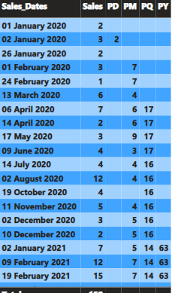
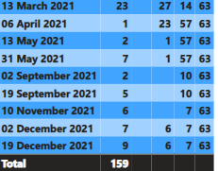
23)DATEADD: By using this, in that date column whatever the Existing dates are there, that dates are moves the given sets of dates by the specified interval.
Syntax: DATEADD(<dates>,<number_of_intervals>,<interval>)
NOTE: The result dates are existing in dates column column then it returns that particular date otherwise it returns Blank.
Dax Function: DADD = CALCULATE(SUM('time'[Sales]),DATEADD('time'[Sales_Dates],-1,MONTH))
24)DATESBETWEEN: By using this, we can return the dates between two dates.
Syntax: DATESBETWEEN(<Dates>, <StartDate>, <Endite>)
Dax Function: DATEBETWEEN = CALCULATE(SUM('time'[Sales]),DATESBETWEEN('time'[Sales_Dates],DATE(2020,02,01),DATE(2020,12,31)))
25)DATESINPERIOD: By using this, we can return the date from the given period.
Syntax: DATESINPERIOD(<dates>, <start_date>, <number_of_intervals>, <interval>)
Dax Function: DATESINPERIOD = CALCULATE(SUM('time'[Sales]),DATESINPERIOD('time'[Sales_Dates],DATE(2020,01,01),1,MONTH))
26)PARLLELPERIOD: By using this, in that date column whatever the dates are there based on interval, that date related value will be displayed for the specified columns of date.
Syntax: PARALLELPERIOD(<dates>,<number_of_intervals>,<interval>)
Dax Function: PARLLELPERIOD = CALCULATE(SUM('time'[Sales]),PARALLELPERIOD('time'[Sales_Dates],1,QUARTER))
Output:
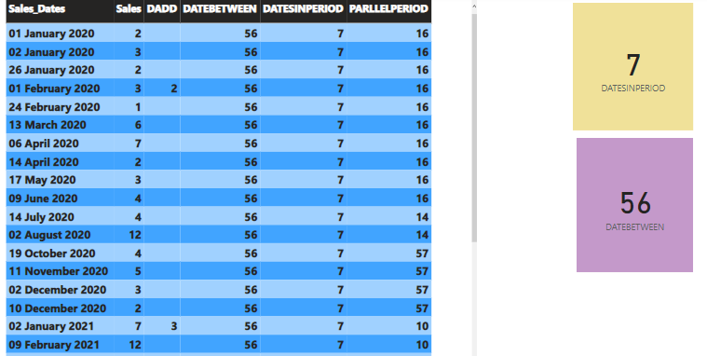
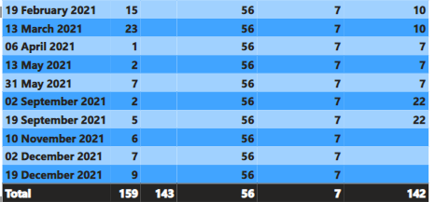
27)DATEMTD: By using this, in that date column whatever the latest date is there , that dates related value will be displayed for the specified columns of date.
Syntax: DATESMTD(<dates>)
Dax Function: DMTD = CALCULATE(SUM('time'[Sales]),DATESMTD('time'[Sales_Dates]))
28)DATEQTD: By using this, in that date column whatever the latest Quarter is there , that dates related value will be displayed for the specified columns of date.
Syntax: DATESQTD(<dates>)
Dax Function: DQTD = CALCULATE(SUM('time'[Sales]),DATESQTD('time'[Sales_Dates]))
29)DATEYTD: By using this, in that date column whatever the latest Year is there , that dates related value will be displayed for the specified columns of date.
Syntax: DATESYTD(<dates> [,<year_end_date>])
Dax Function: DYTD = CALCULATE(SUM('time'[Sales]),DATESYTD('time'[Sales_Dates]))
Output :
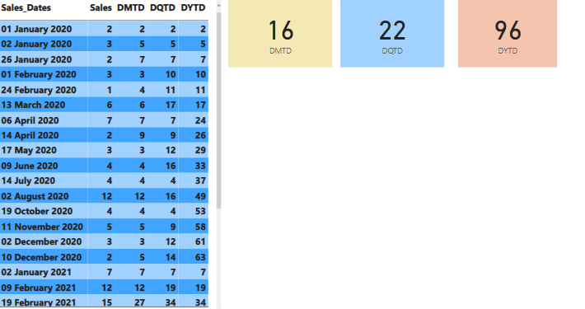
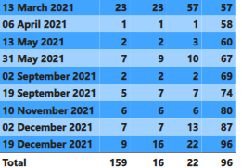

30)TOTALMTD: By using this, in that date column whatever the latest Date is there, that dates related value will be displayed for the specified columns of date.
Syntax: TOTALMTD(<expression>,<dates>[,<filter>])
NOTE: Difference between DATEMTD and TOTALMTD is, DATEMTD works in date dimension but TOTALMTD works from 1 expression to last day of the month.
Dax Function: TMTD = TOTALMTD(SUM('time'[Sales]),'time'[Sales_Dates])

31)TOTALQTD: By using this, in that date column whatever the latest Quarter is there, that dates related value will be displayed for the specified columns of date.
Syntax: TOTALQTD(<expression>,<dates>[,<filter>])
Dax Function: TQTD = TOTALQTD(SUM('time'[Sales]),'time'[Sales_Dates])

32)TOTALYTD: By using this, in that date column whatever the latest Year is there, that dates related value will be displayed for the specified columns of date.
Syntax: TOTALYTD(<expression>,<dates>[,<filter>][,<year_end_date>])
Dax Function: TYTD = TOTALYTD(SUM('time'[Sales]),'time'[Sales_Dates])
Output: 